clear; close all; clc
%NOTE CONCERNING VARIABLE NAME DEFINITION:
%(condition) is used to mean both 'Normal' and 'Afib', for example:
%'(condition)-heartrate' means both Normalheartrate and Afibheartrate
%Also: Variables are created and defined in the first section they are used
%in, but may also be used any subsequent section.
%---DATA CONDITIONING AND DISPLAY---
%Variable Names
%ECG-(condition).....Array containing values of the ECG of the condition
%time................Array of time for the plot.
%Data is uploaded into the workspace
load ECGafib.txt;
load ECGnormal.txt;
time=0:(1/250):((length(ECGafib)/250)-(1/250));
%Data is inverted
ECGafib=-1*ECGafib;
ECGnormal=-1*ECGnormal;
%Two subplots for both conditions' ECGs are created
figure(1);
subplot(2,1,1);
plot(time, ECGnormal);
xlabel('Time (sec)');
ylabel('ECG Signal µV)');
title('ECG Normal');
grid on;
subplot(2,1,2)
plot(time, ECGafib,'r'), hold on;
xlabel('Time (sec)');
ylabel('ECG Signal (µV)');
title('Atrial Fibrillation ECG');
grid on;
%---PQRST DETECTION---
%VARIABLE NAMES:
%(condition)-peak.....Array of the peak heights of condition
%(condition)-index....Array of the index of the peaks of condition
%index................Array of the indecies
%The findpeaks function is used to find both the local maximum
%The maximum must be greater than 1000 microVolts
%The findpeaks function returns the peak value and its corresponding index
%The peaks are then plotted on the ECG.
index=1:2500;
%Peaks are found along with corresponding index
[afibpeak,afibindex]=findpeaks(ECGafib,'MINPEAKHEIGHT',1000);
[normalpeaks,normalindex]=findpeaks(ECGnormal,'MINPEAKHEIGHT',1000);
%ECG is plotted, along with the peaks in green.
figure(2);
subplot(2,1,2);
plot(index, ECGafib,'r'), hold on;
scatter(afibindex, afibpeak, 'g', '*'), hold off;
xlabel('Data Indicies');
ylabel('ECG Signal (µV)');
title('Atrial Fibrillation ECG');
grid on;
subplot(2,1,1);
plot(index, ECGnormal,'b'), hold on;
scatter(normalindex, normalpeaks, 'g', '*'), hold off;
xlabel('Data Indicies');
ylabel('ECG Signal µV');
title('Normal ECG');
grid on;
%---HEART RATE CALCULATION---
%VARIABLE NAMES:
%(condition)-Intervals....Array that shows the heart beat in
% (#seconds/beat)
%(condition)-HeartRate....Array that shows the heart beat in beats per
% minute
%The following 'for' loops compute (#seconds/beat) and
%put them in an array, one for each condition.
for n = 2:12
normalIntervals(n-1)=(normalindex(n)-normalindex(n-1))/250;
end
for n = 2:12
afibIntervals(n-1)=(afibindex(n)-afibindex(n-1))/250;
end
%The heart rate for each condition is computed here.
normalHeartRate=(1./(normalIntervals)).*60;
afibHeartRate=(1./(afibIntervals)).*60;
%The heart rate is then plotted for each condition
figure(3);
plot(normalindex(1:11),normalHeartRate,afibindex(1:11), afibHeartRate);
xlabel('Data Indicies');
ylabel('Heart Rate (Beats per Minute)');
title('Heart Rate');
grid on;
legend('Atrial Fibrilation Heart Rate','Normal Heart Rate',...
'Location','northwest');
%The average heart rate for both conditions is displayed in the
%command window
disp(['The normal heart rate detected is ',...
num2str(mean(normalHeartRate)),' beats per minute']);
disp(['The afib heart rate detected is ',...
num2str(mean(afibHeartRate)),' beats per minute']);
%---PQRST EXTRACTION AND AVERAGING---
%VARIABLES
%(condition)-ECG...........Array containing all the PQRST complexes for the
% corresponding condition's ECG
%(condition)-Ave...........Array containing the average PQRST complex
%time......................Array for time for the plot.
%Two arrays, one for each condition, are created with only zeros
NormAve=zeros(221,1);
AfibAve=zeros(221,1);
time=0:1/250:0.88;
NormECG=zeros(221,12);
AfibECG=zeros(221,11);
%Each Array is loaded with the PQRST complexes detected
for n=1:12
NormECG(:,n)=ECGnormal(normalindex(n)-110:normalindex(n)+110)';
end
for n=2:12
AfibECG(:,n-1)=ECGafib(afibindex(n)-110:afibindex(n)+110)';
end
%Average of each row of the ECG array is assigned to the average
%array in a 'for' loop.
for n=1:221
NormAve(n,1)=mean(NormECG(n,:));
end
for n=1:221
AfibAve(n,1)=mean(AfibECG(n,:));
end
%Plot of the average PQRST complex is created with a legend
figure(4);
plot(time,NormAve,'r',time,AfibAve);
xlabel('Time (sec)');
ylabel('µV');
title('Average PQRST complex');
legend('Normal Average',...
'Atrial Fibrilation Average',...
'Location','northwest');
legend('boxoff'); %Removes box around legend due to it
%interfering with the plot
%---TOTAL AVERAGE POWER---
%Variable
%Ave-(condition)-Power.......Average power of PQRST, in Watts.
%Total Average Power for each condition is computed here
AveNormalPower=((1/length(NormAve))*(sum((NormAve).^2)));
AveAfibPower=((1/length(AfibAve))*(sum((AfibAve).^2)));
%Total Average Power is displayed for each condition
disp(['The Total Average Power of Normal Average PQRST is ',...
num2str(AveNormalPower),' Watts.']);
disp(['The Total Average Power of Afib Average PQRST is ',...
num2str(AveAfibPower),' Watts.']);
The normal heart rate detected is 74.3357 beats per minute
The afib heart rate detected is 72.374 beats per minute
The Total Average Power of Normal Average PQRST is 38544.2788 Watts.
The Total Average Power of Afib Average PQRST is 40400.3603 Watts.
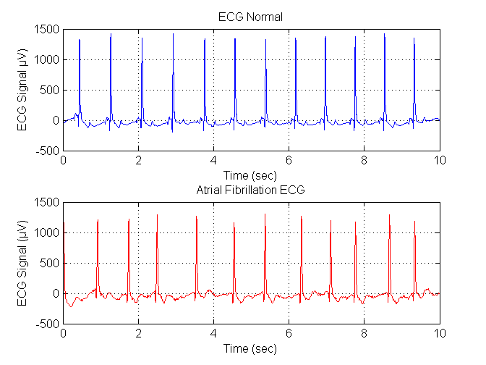
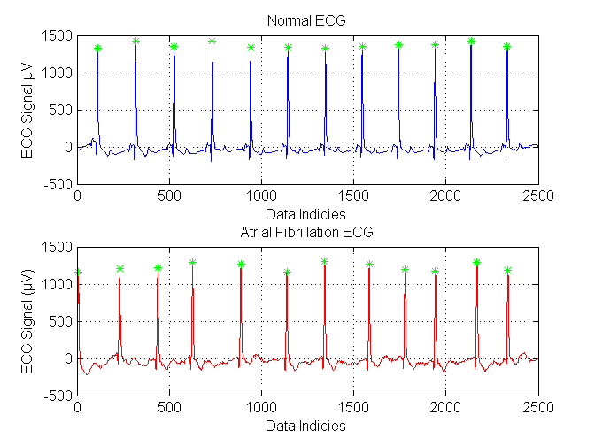
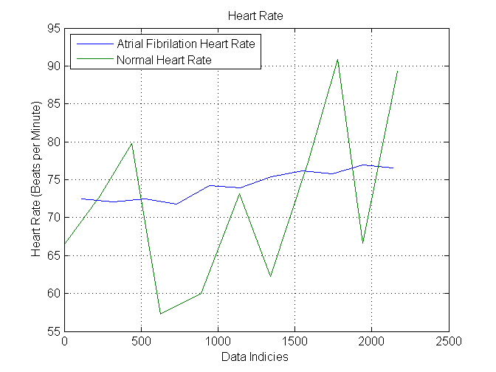
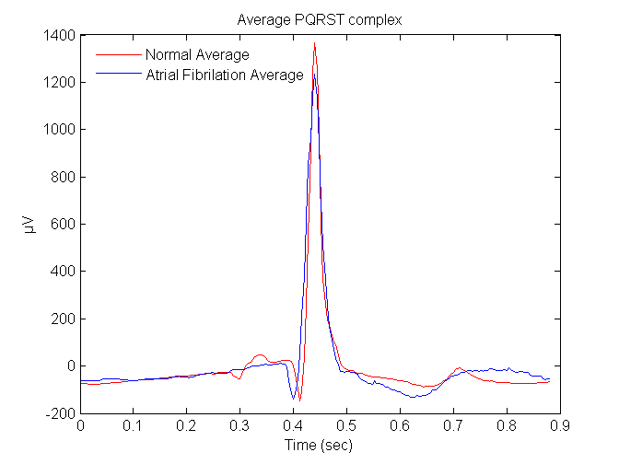
Published with MATLAB® R2014a

